IEEE *** Roadmap White Paper Template

Trademarks

Acknowledgments

Table of Contents
Introduction 1
Why a <<name of workstream topic>> Roadmap Matters… 1
Vision 1
What You Will Learn… 2
Roadmap Charter 2
White Paper Scope 3
Grand Challenges for xx 3
Linkages and Stakeholders 3
Focus Areas Needs, Challenges, Solutions 4
Focus Area—<<Name of Focus Area 1>> 4
Focus Area—<<Name of Focus Area 2>> 8
Conclusions and Recommendations 11
Future Assessments 11
Next Steps 11
Glossary 12

List of Figures
Figure 1 Example Title 1 6
Figure 2 Example Title 2 6

List of Tables
Table 1 Timeline of Needs, Challenges, Solutions Summary for <<Name of Focus Area1>> 5
Table 2 Timeline of Needs, Challenges, Solutions Summary for <<Name of Focus Area2 >> 8

Abstract

Key words

Introduction
Instruction: This white paper gives a broad summary of what one can expect from the more in-depth roadmap effort for this workstream topic. It describes a high-level perspective and projection of the workstream topic’s status, in particular the challenges and gaps to be explored and reported.
The Introductory sections of this white paper are summaries of scope, charter, stakeholders, expected linkages and may include a summary of the top challenges for this overall workstream.
NOTE: This roadmap does not endorse any one solution, company, or research effort. Please do not name specific entities, but generalize instead.
Length = ½ to 1 page

Why a <<name of workstream topic>> Roadmap Matters…
Instructions: This sub-section is an impact statement and should state the need for a roadmap effort for this workstream.
Question 1 - Why is there a need for such a focus as a roadmap?
Question 2 – What are the benefits to industry, research, society, etc. as part of the roadmap effort? For example, technical (focused research, cost sharing, partnerships/projects, supply chain health) or social (community building, engagement, technical knowledge sharing, work force development).
Question 3 – What happens without this roadmap?
Length - Brief, 1 paragraph narrative and a list of bullets.

Vision
Instructions: This sub-section describes the high-level aspiration for this roadmap effort, based on the IEEE mission and vision of bettering humanity and common good.
Question 1 – How does this roadmap effort realize the IEEE mission and vision?
Question 2 – What are the long-term ambitions of producing this roadmap (e.g., short-term, long term)?
Length = ½ page

What You Will Learn…
Instructions: This sub-section summarizes the key messages of the roadmap, based on each focus area.
Question 1: What are the relationships of the focus areas to the main roadmap workstream and why are they important?
Question 2: What expectations can the reader have for reading/using/sharing this roadmap?
Question 3: What are the key take aways of this roadmap?
Length = 1-3 paragraphs

Roadmap Charter
Instruction: With respect to the specific workstream, what is the ideation for this roadmap effort ?
Question 1: What is the short-term and long-term goals of the roadmap effort, such as expectations for use and implementation of its assessments?
Question 2: What is the goal of the roadmap volunteer community for this workstream?
Length = ½ - 1 page

White Paper Scope
Instruction: (This sub-section for scope is a summary description of the roadmap elements (needs, status, challenges, solutions) to be determined during the subsequent workstream roadmap process.).
Additionally, this sub-section presents a brief framework of the workstream roadmap, such as the time horizon of the roadmap and considerations that could be included. This can be a graphic.
Question 1 – What does this white paper present, as described by proposed focus areas that the workstream roadmap intends to cover? (What is in scope, AND what is out of scope?). Summarize the proposed focus areas for the workstream roadmap.
This can be a list with each focus area description or definition.
Question 2 – What is the scope of the Workstream roadmap.
Question 3 – If appropriate, list the market or business drivers for the workstream? (List as verticals/applications/services.)
Length = 1 page)

Grand Challenges for xx
Instruction: Present a list of the top 5-10 challenges for all the Focus Areas for this Workstream roadmap. These should include an item name and then explanation of why it is a challenge. These can be presented as “near-term” challenges (1-4 year time horizon and “long-term” (5-10 year time horizon) challenges. This can be a table.
Length = 1 page

Linkages and Stakeholders
Instruction: Who is impacted by this roadmap topic? (Explain the relationships with this topic and amongst the various stakeholders.
Question 1 – Who are all the types of organizations and specific entities (such as standards, consortia, partnerships, regional research hubs, government agencies, suppliers, operators, end users, as well as type of industries, etc.)?
Question 2 – Who are other roadmap teams that this roadmap will need to share information with to coordinate with roadmap timing and solutions?
Question 3 – Which are the standards bodies should participate in creating this roadmap?
Question 4 – Who/what are the other enabling technologies and organizational capabilities (education, regulators, infrastructures, policy, etc.)?
Length = 1 page, can be lists or bullets preceded by an explanatory sentence

Focus Areas Needs, Challenges, Solutions
Instruction: This main section of Focus Areas includes sub-sections for each Focus Area topic. A key component of this section is the timeline of needs, challenges, and solutions summary table. Each of the sections for State of Art/Current State, Future State and Challenges provide explanatory narrative for the table.

Focus Area—<<Name of Focus Area 1>>

Overview
Instruction: Present a summary of this Focus Area and its importance to people. Length is 3-5 paragraphs and includes bulleted lists.
Questions to consider:
What is the definition of this Focus Area for the main roadmap topic?
What does this Focus Area include (scope of discussion)? This can be a list.
Why is this Focus Area important?
What are the positive impacts? What are any “showstoppers” or critical challenges?
Point to the summary table below for timeline of needs, challenges, solutions summary for <<Focus Area #1 Name>>.

Roadmap Assessment Summary
Instruction: List each need/challenge/solution set in the Summary Table. Keep all items brief. It is recognized this is an assessment only at this point in time.
Add rows as needed. Content can span across multiple timeframes.
- Timeline of Needs, Challenges, Solutions Summary for
<<Name of Focus Area1>>
Name (be brief) | Current State  (YYYY)  (details) | 5 years  (YYYY)  (details) | Future State  10-years (YYYY)  (details)
Need #1
Challenge(s) for Need 1
Possible Solution for Challenge
Need #2
Challenge(s) for Need 2
Possible Solution for Challenge
Need #3
Challenge(s) for Need 3
Possible Solution for Challenge
Need #4
Challenge(s) for Need 4
Possible Solution for Challenge
Need #5
Challenge(s) for Need 5
Possible Solution for Challenge

State of Art
Instructions: Includes the current state of all aspects of this Focus Area topic. Describe the current landscape of the Focus Area topic as it is today.

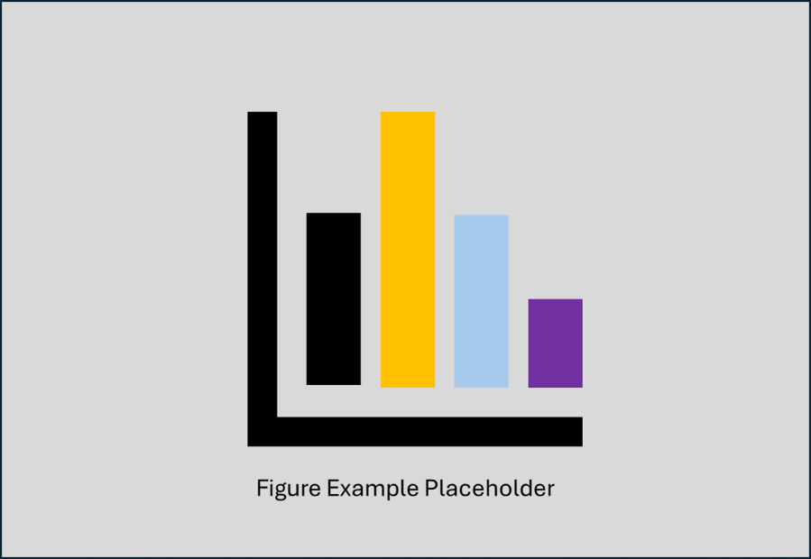
- Example Title 1

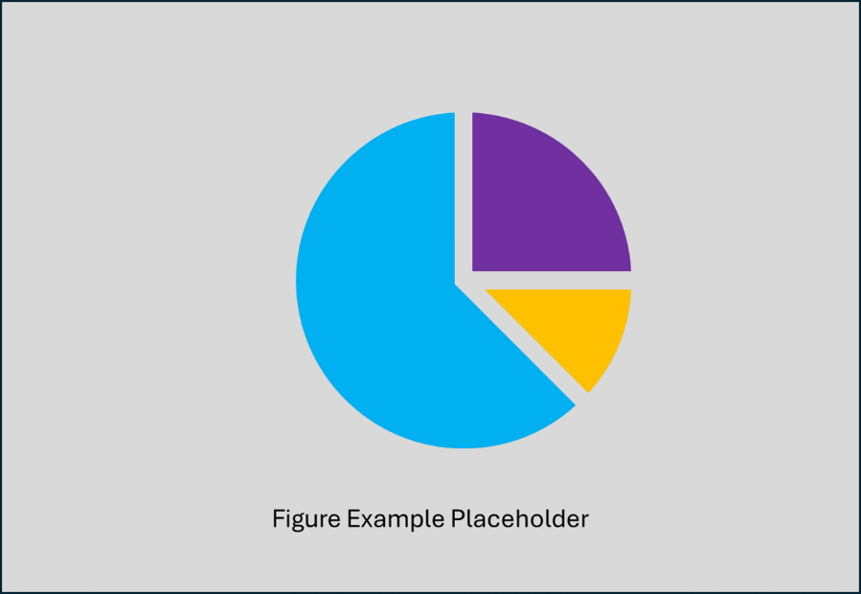
- Example Title 2

Future State
Instruction: Describe landscape and/or capabilities’ targets within the 10-year horizon. Length – 3-5 paragraphs

Challenges and Solutions
Instruction: Describe critical challenges for the Focus Area topic within the 10-year horizon. Interim points at the 5- and 10-year time frames can be described.
Can be a set of bullets or a table, with explanatory narrative of 3-5 paragraphs

The Team (<<Name of Focus Area>>)
Instructions: Names with affiliations, no contact information

References
Instructions: These will be as Endnote references for cited works and bibliography for each Focus Area section and sequentially numbered. “General” references will also be included here.

Focus Area—<<Name of Focus Area 2>>

Overview
Instruction: Present a summary of this Focus Area and its importance to people. Length is 3-5 paragraphs and includes bulleted lists.
Questions to consider:
What is the definition of this Focus Area for the main roadmap topic?
What does this Focus Area include (scope of discussion)? This can be a list.
Why is this Focus Area important?
What are the positive impacts? What are any “showstoppers” or critical challenges?
Point to the summary table below for timeline of needs, challenges, solutions summary for <<Focus Area #2 Name>>.

Roadmap Assessment Summary
Instruction: List each need/challenge/solution set in the Summary Table. Keep all items brief. It is recognized this is an assessment only at this point in time.
Add rows as needed. Content can span across multiple timeframes.
- Timeline of Needs, Challenges, Solutions Summary for
<<Name of Focus Area2 >>
Name (be brief) | Current State  (YYYY)  (details) | 5 years  (YYYY)  (details) | Future State  10-years (YYYY)  (details)
Need #1
Challenge(s) for Need 1
Possible Solution for Challenge
Need #2
Challenge(s) for Need 2
Possible Solution for Challenge
Need #3
Challenge(s) for Need 3
Possible Solution for Challenge
Need #4
Challenge(s) for Need 4
Possible Solution for Challenge
Need #5
Challenge(s) for Need 5
Possible Solution for Challenge

State of Art
Instructions: Includes the current state of all aspects of this Focus Area topic. Describe the current landscape of the Focus Area topic as it is today.

Future State
Instruction: Describe landscape and/or capabilities’ targets within the 10-year horizon. Length – 3-5 paragraphs

Challenges and Solutions
Instruction: Describe critical challenges for the Focus Area topic within the 10-year horizon. Interim points at the 5- and 10-year time frames can be described.
Can be a set of bullets or a table, with explanatory narrative of 3-5 paragraphs

The Team (<<Name of Focus Area>>)
Instructions: Names with affiliations, no contact information

References
Instructions: These will be as Endnote references for cited works and bibliography for each Focus Area section and sequentially numbered. “General” references will also be included here.

Conclusions and Recommendations

Future Assessments

Next Steps

Glossary
Abbreviations/Acronyms
Term | Definition

Curious for more information about this Roadmap effort or to participate?
Please contact ….

*** Roadmap Website

For more information about the IEEE *** Society
Please contact…

Website

About IEEE
IEEE is the world's largest technical professional organization dedicated to advancing technology for the benefit of humanity.
IEEE Mission & Vision
Mission statement
IEEE's core purpose is to foster technological innovation and excellence for the benefit of humanity.
Vision statement
IEEE will be essential to the global technical community and to technical professionals everywhere, and be universally recognized for the contributions of technology and of technical professionals in improving global conditions.
Learn more about IEEE
Ieee.org

The IEEE vision and mission statements are as follows, respectively: “IEEE's core purpose is to foster technological innovation and excellence for the benefit of humanity.” “IEEE will be essential to the global technical community and to technical professionals everywhere, and be universally recognized for the contributions of technology and of technical professionals in improving global conditions.”

